Stores

Phase: Rough Draft (High Level, Rough Draft, Final Design, Done)

Status: Ready for Review (Work in Progress, Ready for Review, Approved)

Reviewers | Table Read Date
Josh Bridge  Al Jarvie  Ole Uttuslien | July 04, 2011

Link to TDD
Feature Design Technical Design Document

CONTENTS
- CONTENTS
- VISION
  - ANTI-VISION
- FEATURES
  - RETAIL SUPPLY LOCATIONS
    - RETAIL INTERIOR
    - RETAIL EXTERIOR
    - BREAKABLE GLASS vs. NON-BREAKABLE GLASS
  - NON-RETAIL SUPPLY LOCATIONS
    - TREASURE CHEST VEHICLES
    - ALTERNATE STORE EXAMPLES
  - RETAIL CATEGORIES
  - STORES BY DISTRICT
    - CENTRAL CITY - WIP (subject to change)
    - SUNSET HILLS - WIP (subject to change)
    - INGLETON - WIP (subject to change)
    - SOUTH ALMUDA - WIP (subject to change)
    - FREEWAY - WIP (subject to change)
  - REQUIREMENTS
  - AUDIO
  - VISUAL FX

VISION
Supplies in the city-wide zombie apocalypse are anywhere and everywhere you go.
- know what i can enter/not enter
- know what the product is from a glance
- celebration of americana - silhouettes, signage in camera view

ANTI-VISION
Shopping Malls
- confusion about what is and isn't accessible
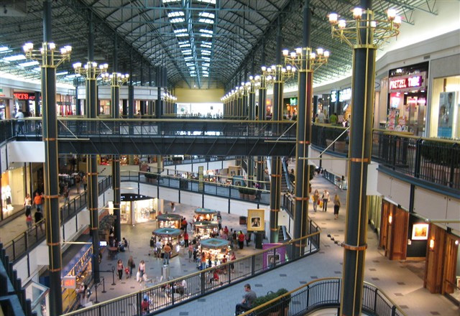

FEATURES
- World map supply locations
- Supply Locations
  - Retail
    - Interior
    - Exterior
    - Breakable Glass
  - Non-Retail
    - Found Anywhere
  - Other Supply pick ups
- Enter-able vs. Non Enter-able Locations
- Item regeneration
  - time based
  - distance based
- Supplies categories
- DR2 re-use

RETAIL SUPPLY LOCATIONS
Retail supply locations are common stores found throughout the world.

RETAIL INTERIOR
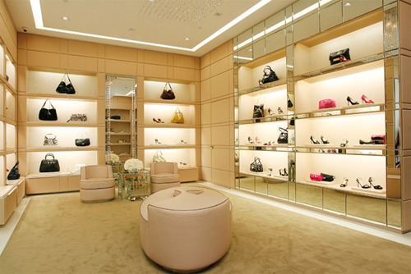

RETAIL EXTERIOR
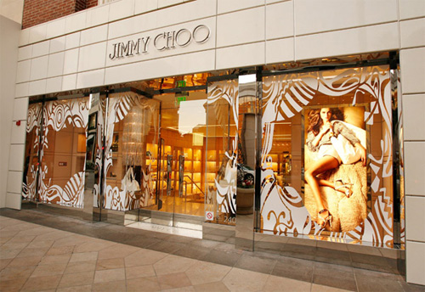

BREAKABLE GLASS vs. NON-BREAKABLE GLASS
All glass that is not barred or laced with wire can be broken by the player, COOP player and zombie glass bangers.
- Can be broken:
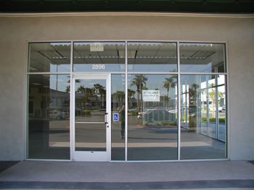

- Can not be broken:
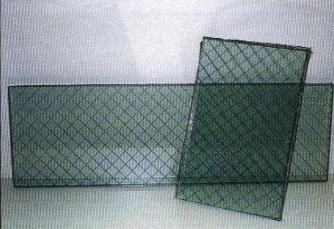

- Non-breakable glass receives a smash decal
- reinforces to the player that the glass cannot be broken
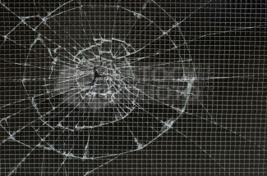

NON-RETAIL SUPPLY LOCATIONS
Non-retail locations are common stashes of supply found throughout the world.
Visual indicators for these alternate stores will be required so that they still stand out in the world. Such as:
- brighter in color and or unique in color
- graffiti markings
- unique audio emitter

TREASURE CHEST VEHICLES
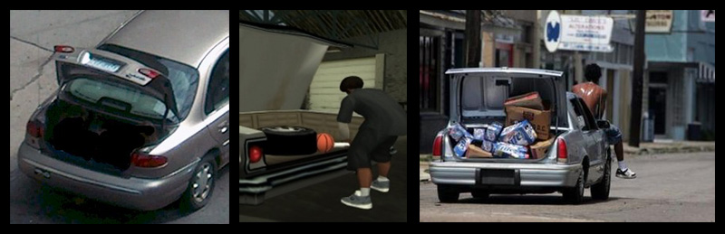

Non-drivable vehicles that the player can interact with to open the doors and trunks to search for weapons and items.
- Items are pre-placed like any other item inside the car

ALTERNATE STORE EXAMPLES
Interior of modern sunset hills house
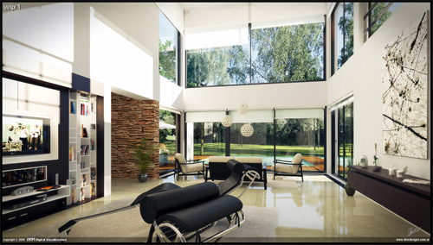

- interior of modern sunset hills garage:
- 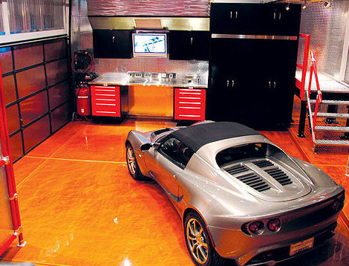
- back yard tree house in low-end sunset hills:
- 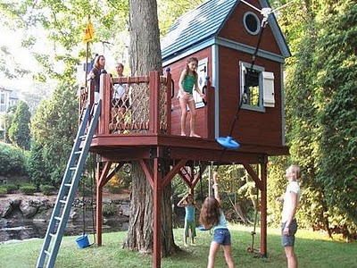
- yard sale in ingleton
- 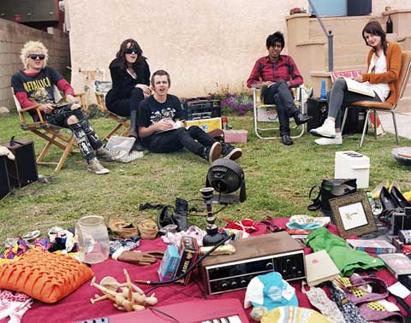
- back yard in ingleton:
- 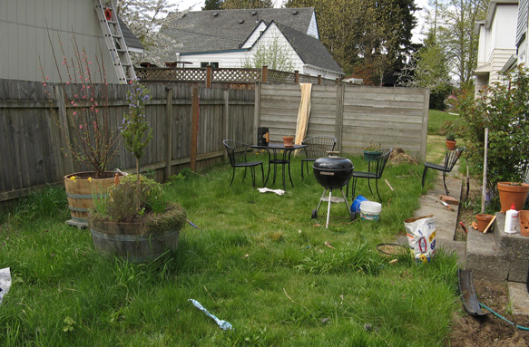
- open moving truck in ingleton:
- 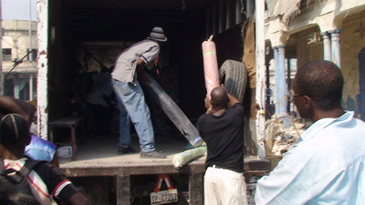
- picnic in the park in Central City:
- 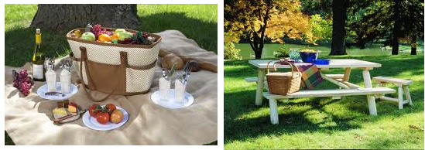
- construction area in Central City:
- 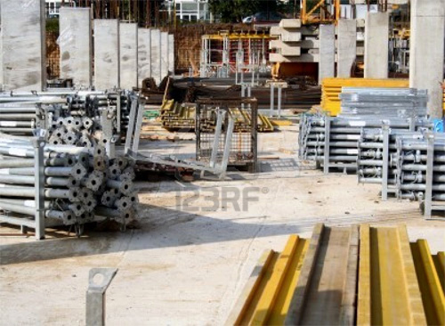
- Shipping containers in South Almuda:
- 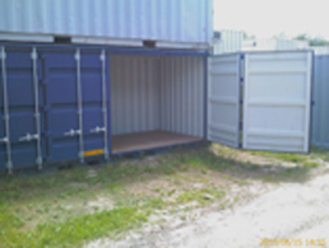
- Dumpsters in South Almuda:
- 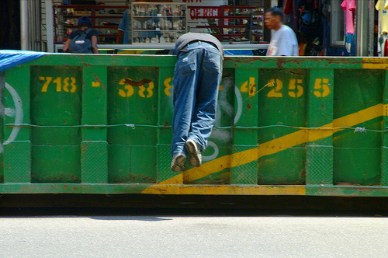

RETAIL CATEGORIES
- Accessories (DR2)
- Arms & Security
- Automotive
- Beautification (DR2)
- Clothing - Children (DR2)
- Clothing - Men (DR2)
- Clothing - Unisex (DR2)
- Clothing - Women (DR2)
- Electronics (DR2)
- Fitness (DR2)
- Food (DR2)
- Home & Garden
- Music & Entertainment (DR2)
- Novelty & Gifts
- Pharmaceutical
- Services (DR2)
- Special Interest
- Sports & Recreation
- Tools & Hardware
- Toys & Hobbies (DR2)
- Travel (DR2)

STORES BY DISTRICT

CENTRAL CITY - WIP (subject to change)
RETAIL | NON-RETAIL | TOTAL | DR2 Reuse | NEW
24 | 4 | 28 | 13 | 16

# | Retail Category | Names  Suggested | Inventory | DR2 Reuse | Notes
1 | Accessories | Family  Jewels  Carbon & Heat  Pearl  Neclace  Bling it On!  Pinky's Diamonds  Big Rocks | Jewelry | Everything Diamond | New Frontage
2 | Accessories | Shockerz  Karmen  Affordit  Golddiggers  Central Boutique | Fashion Accessories
3 | Accessories  Clothing | Z & G  Yog's Bags  YOG | Handbags and Accessories | Bagged! | New Frontage  Requires survivor enterable change room
4 | Automotive | Speed Demons  Angels Auto  Wendels Whips and Rides  Boost!  Vin Paul's Luxury Cars | Exotic Vehicles
5 | Beautification | Johann Salon  Unbeweavable  Boufont  Strands  Jerry's Curls  Pouffe  Curtains and Carpets | Hairstylist | Wave of Style
6 | Beautification | Lacquer  Cover Me Up  Face It | Cosmetics | FairMoans
7 | Clothing Men | Strappin' Tall  Altitude  Hexx  Comforts | Casual Wear | Albert's Apparel | New Frontage
8 | Clothing Men | Wentworth's  Onyx  Modern Businessman  Modern Man | High Fashion | Wallington's | New Frontage
9 | Clothing Unisex | Chap-oh  Chap Oh  Dand Ruff  Brimms  Cap'n | Hats | Que's Hats
10 | Clothing Unisex | Made in China  2 for 20  Two for Twenty  Chinamade  Chinawear  The Sweat Shoppe | Shirts and Sunglasses
11 | Clothing Women | Imelda's  Esther's  Heels Good  Pumps  Pumps me Up  Stilleto's | Shoes | Kicks for Her | New Frontage
12 | Clothing Women | Dudette  In There Swimwear  Beach Bodies  Strings  Bodysuit  Wet Wear | Beach Wear
13 | Clothing Women | Shhhh!  La Vivaneau  Lace  Whisper Wear  Sattin's Fine Silks  Cie-thru | High End Lingerie/Underwear
14 | Electronics | Aduna's Mobile  Hear me Now  Core  Calldrop  The Line  Callisto | Cell Phones | Robsaka Mobile
15 | Food | Cupcake Mistress  Sweet Enuff  Sweet Tooths  Cavities  Surgarfulls  Icing on the Cupcake  Iced On  Callistos Cakes | Sweets and Candy
16 | Food | Central Bistro  Dilly's Grill  Feed Bag  Gastro City  Ron's Beach Front Bistro  Seafront Bistro | Casual Bistro
17 | Music & Entertainment | Tribute Bowl  Central City Amphitheater  The Pavilion | Outdoor Theater Stage |  | Requires massive stage setup and destructible speakers
18 | Services | The Featherworth  The Burgess-Dawson | Hotel |  | Requires safe area around pool for Old lady  Stronghold map
19 | Novelty & Gifts | Central Gifts  Nifty Gifts  Gifties  Shifty's | Gift Kiosk | TIR Souvenir Kiosk | Partial reuse
20 | Sports Equipment |  | SporTrance
21 | Services | Sculpt Yourself  Tight n Smooth  LIfts  Renew | Cosmetic Surgery
22 | Services | Caught my Eye  Squintless  Dark Shades | Sunglass Display | Finders Peepers | Transform into Kiosk
23 | Services | Central City Police | Police Station |  | Story Location
24 | Special Interest | Boomshika's  Gallerie Zarathustra  Jacquelline Hermes | Art Gallery | The Cleroux Collection
25 | Special Interest | Central City Museum  Gould Museum | Museum |  | Story Location
26 | Sports & Recreation | Deals of Wheels  Pedals  Spokes  Endo's Bikes  Off the Chain  Wheelies  Treads and Trails | Bike Rental
27 | Sports & Recreation | Boards  Dude Where's my Board  Dreadlocks  Surf n Turf  Kahuna's Waxx  Sharkbite's Surf Shop  Stoked!  Knarly's | Surf and Skate shop
28 | Sports & Recreation |  | Beach Front Tennis |  | Part of World
29 | Sports & Recreation |  | Recreational Walkway |  | Part of World
30 | Sports & Recreation | DELETE ME | sports equipment and clothing | Sportrance/Kokonutz Sports Town | Interior Use only

SUNSET HILLS - WIP (subject to change)
RETAIL | NON-RETAIL | TOTAL | DR2 Reuse | NEW
18 | 8 | 26 | 13 | 13

# | Retail Categories | Names  Suggestions | Inventory | DR2 Reuse | Notes
1 | Arms & Security |  | Gun Cabinet in garage
2 | Automotive | Autobauns  Jack's Car Retal  Deiter Does Cars | Car Rental
3 | Clothing Children |  | Casual Kids | Kid's Choice Clothing
4 |  |  | Uptown Kids | Stylin' Toddlers
6 | Clothing Women |  | Women's Celeb Closet
7 | Fitness |  | Yoga
8 | Food |  | Sushi | Luaii Wauwii | Interior Prop reuse only
9 | Food |  | Mexican | Rojo Diablo Mexican Restaurant
10 | Food |  | Casual Cafe | Speedy Espresso | Add interior seating area
11 | Food |  | Family Restaurant
12 | Food |  | Steakhouse | Wild West Grill House
13 | Food |  | Liquor Store | Leigh's Fine Liquor
14 | Home & Garden |  | Fancy Furniture
14b |  |  | Dirty House - older home, tucked away from main strip |  | House needs to be created so that Zombies cannot escape it. Also requires functional closet on second floor big enough for a human to fit inside.
15 |  |  | Fancy House |  | Requires Wine Cellar for side mission
16 |  |  | Senator's Mansion |  | Sloth Psycho Battle  Nice Mansion - Highly Explorable
17 |  |  | Modern Celeb House |  | Requires room with heart-shaped bed see SM-52 Zombies gone wild
17b | Home & Garden |  | Family Home |  | Must contain one large front room
18 |  |  | Hollywood House |  | Entire house not accessible Requires pool out back - drained of water. Deep enough that zombies cannot get out of it.
19 |  |  | Backyard + Treehouse |  | Should be pass-through more secret
20 | Music & Entertainment |  | Nightclub/Karoke | Pub O Gold
21 | Music & Entertainment |  | Music Instruments | Tunemakers
22 | Pharmaceutical |  | Drug Store | Roy's Mart
23 | Services |  | Divorce | Severed Ties | Change from Kiosk to Store with Frontage
24 | Home & Garden |  | House Under Construction | New Home | Exterior accessible only, maybe one room as pass-through
25 | Tools & Hardware |  | Local Hardware Store | Big Buck Hardware  (Case Zero) | Interior Prop reuse only
26 | Toys & Hobbies |  | Unique Kids Toys | Ultimate Playhouse | Interior Prop reuse only

INGLETON - WIP (subject to change)
RETAIL | NON-RETAIL | TOTAL | DR2 Reuse | NEW
18 | 11 | 29 | 9 | 20

# | Retail Categories | Suggested Names | Inventory | DR2 Reuse | Notes
IN101 | Arms & Security | Shanks | Bladed Weaponry
IN102 | Arms & Security | Headshots | Generic Gun Store
IN103 | Arms & Security | Worth a Shot | Specialty Gun Store
IN104 | Arms & Security | Crack House | Crack House Weapon Depot
IN105 | Automotive | Dave’s Awesome Cars | Used Car Sales
IN106 | Beautification | Shavey’s | Barber Shop | Barber Shop (Case Zero) | Interior Prop reuse only
IN107 | Electronics | U Break Wii Fix  Zheng Computer | Used Computer Repair Center
IN108 | Fitness |  | Garage Workout | Flexin' | Interior Props only
IN109 | Fitness | Aduna’s Gym | Ghetto Gym | Flexin' | Interior Props only
IN110 | Food | Uncle Billys Buffet | Chain Fast Food
IN111 | Food | Hamburger Fiefdom | Chain Fast Food | Hamburger Feifdom | New Frontage
IN112 | Home & Garden | Low Cost Luxury | Low-end Furniture
IN113 | Home & Garden |  | Bum Hut A
IN114 | Home & Garden | Lee-Aimes Estates | Low-rise Apartment
IN115 | Home & Garden | Matt’s House | Back Yard
IN116 | Music & Entertainment |  | The Diamond Panty |  | Story Location
IN117 | Pharmaceutical | Roy’s Mart | Local Drug Store | Roy's Mart
IN118 | Pharmaceutical | Happy Good Mart | Chinese Tinkture Shop
IN119 | Special Interest | Sunny Luck Fortune | Fortune Teller
IN120 | Sports & Recreation | Mingxiang Gardens | Chinatown Garden
IN121 | Sports & Recreation | Ingleton Park | Gangland Park/Basketball Courts
IN122 | Tools & Hardware | Big Buck Deliveries | Hardware Delivery Truck
IN123 | Tools & Hardware | Big Buck’s Hardware | Mom and Pop Hardware Store | Big Buck's Hardware | Interior Props only
IN124 | Travel | Flying Duck Travel Center | Asian Travel Agency | Under the Sea Travels | Interior Props only
IN125 | Other | St. Keith’s Chapel | Crematorium/Funeral Home |  | Story Location
IN126 | Other | St. Keith’s Memorial Grounds | Memorial Grounds |  | Requires at least one crypt that the player can stand on
IN127 | Music & Entertainment | Paradise Platinum Screens | Theater | Paradise Platinum Screens | Interior Props only
IN128 | Home & Garden |  | Bum Hut B
IN129 | Automotive | Zip Gas | Gas Station Convenience Store | Gas Station Store Area (Case Zero) | Interior Props only

SOUTH ALMUDA - WIP (subject to change)
RETAIL | NON-RETAIL | TOTAL | DR2 Reuse | NEW
4 | 15 | 19 | 6 | 13

# | Retail Categories | Suggested Names | Inventory | DR2 Reuse | Notes
SA101 | Accessories | Two for Twenty | Cheap Eyewear | Universe of Optics | Interior Props only
SA102 | Automotive | Speed Demons Auto Worx | Underground Autobody
SA103 | Automotive | Los Perdidos Police Impound | Impound Lot
SA104 | Automotive | Big Buck Heavy Equipment Rental | Forklift Rental Service
SA105 | Clothing Men | Los Perdidos Fire Station No. 5 | Fire House Equipment Locker
SA106 | Clothing Unisex | Big Man’s Clothing | Men’s clothing | For Your Leisure | Interior Props only
SA107 | Clothing Unisex | The Jean Patch | Thrift Store
SA108 | Clothing Women | La Fawnda’s Fabric Outlet | Fabric Warehouse | Trendy Cindy | Interior Props only
SA109 | Food | Special J’s Cafe | Fast Food Kiosk | DR2 Hot dog cart
SA110 | Food | Old Stillhouse ’97 Diner | Food Train
SA111 | Music & Entertainment | Speedy’s G Spot | Trucker Strip Club |  | Requires pimp pad on second floor
SA112 | Novelty & Gifts | Uno Grande Outlet | Dollar Store Warehouse
SA113 | Food | Pirate’s Catch Seafood Restaurant | Seafood |  | Interior Props only
SA114 | Special Interest | Lao’s Cream Dream | Massage Parlour
SA115 | Special Interest | Annie’s Old Fashioned XXX Supply | XXX Party Supplies | Hot Excitorama
SA116 | Special Interest | Special J’s Cafe | Plant Growing Supplies
SA117 | Tools & Hardware | Big Buck Construction Site | Construction Yard
SA118 | Other | Los Perdidos Bus Depot | Bus Depot
SA119 | Other | Warehouse A – 119 | Warehouse (Plane Hangar) | DR2 (Case West)
SA120 | Special Interest | Almuda Farms Cold Storage | Cold Storage |  | Psycho Battle Location
SA121 | Tools & Hardware |  | Construction Dumpsters
SA122 | Special Interest | Rocket’s Red Glare | Import/Export Fireworks | Rockets Red Glare | Inventory Reuse
SA 123 | Novelty & Gifts |  | Tobacco & Gifts
SA 124 | Other | South Almuda Power Plant | Electrical Power Plant
SA 125 | Other | Collins Chemical | Chemical Plant
SA 126 | Other | Fiefdom Meat Suppliers | Meat Processing
SA 127 | Other | South Almuda Recycle Depot | Recycle Depot
SA 128 | Other | Bob’s Super Tires | Tire Shop
SA 129 | Other | Uno Grande Outlet | Toy Factory
SA 130 | Other | Zip Gas | Gas Station - Mini Mart

FREEWAY - WIP (subject to change)
RETAIL | NON-RETAIL | TOTAL | DR2 Reuse | NEW
1 | 4 | 4 | 1 | 3

# | Retail Category | Inventory | DR2 Reuse | Notes
FW101 | Automotive | Rhonda's Autobody | Gas Station (Case Zero) | Inventory/Junkyard Story Location
FW102 | Food | Truckstop Diner (Wrench-o-Rhonda)
FW103 | Automotive | Vehicle Delivery Truck (Speed Demons)
FW104 | Food | Mobile Food Truck (Hamburger Fiefdom)
FW105 | Home & Garden | House and Home Delivery Truck (El Mode)

REQUIREMENTS
- Streaming Requirements
  - Player must never be out of sync with the streamer
  - zones must have siblings to all visible zones from any given zone
  - item population can never exceed the max cap of 1400 items per district
- Breakable glass
  - Player can break glass with skill moves
  - Player can break glass with coop skill moves
  - Player can break glass by knocking zombies into it
  - Survivors can break glass with weapons
- Zombie glass bangers
  - Zombies can break glass by banging on it for a duration of time. See Zombies

AUDIO
- Some world locations will require unique audio

VISUAL FX
- Some world locations will require unique visual effects

